1. **Write a for loop to print the numbers from 1 to 20.**

for (var i=1; i<=20; i++) {

    console.log(i)

}

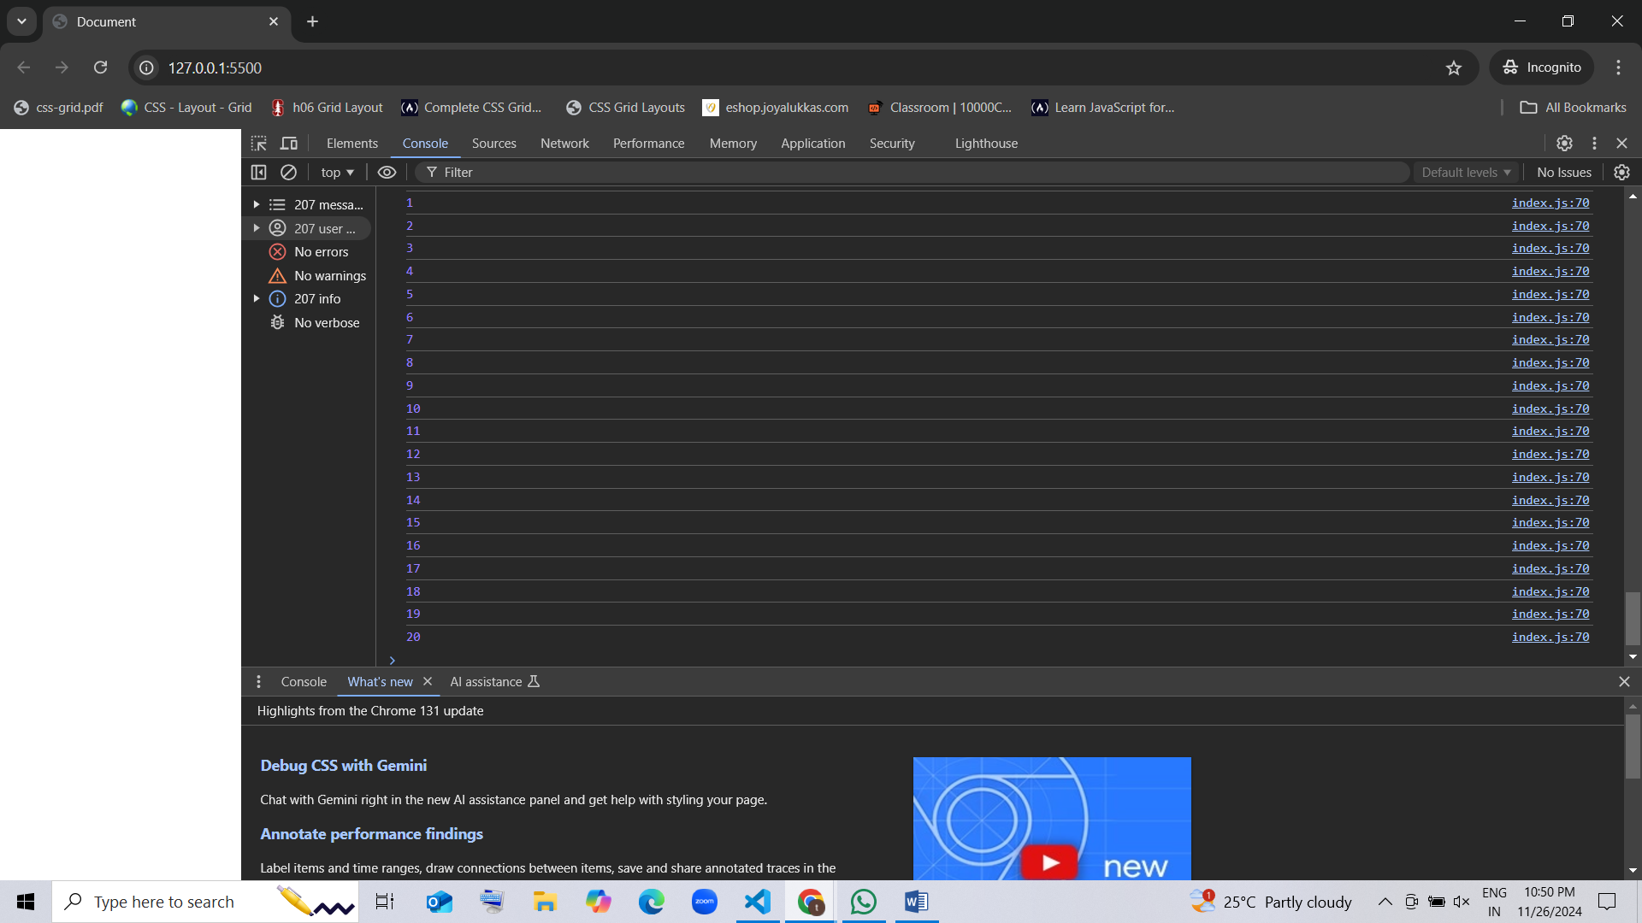

1. **Create a for loop to print the squares of numbers from 1 to 10.**

for (var i=1; i<=10; i++) {

    console.log(i*i)

}

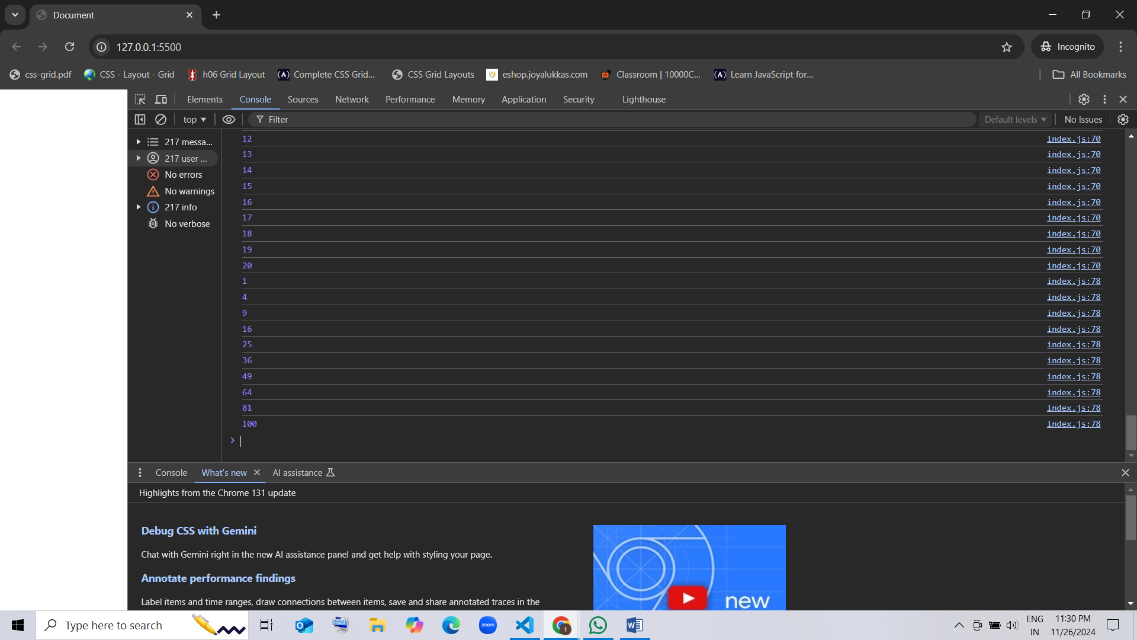

1. **Use a for loop to print the first 10 multiples of 5.**

for (var i=1; i<=10; i++) {

    console.log(5*i)

}

for (var i=1; i<=10; i++) {

    console.log(i*5)

}

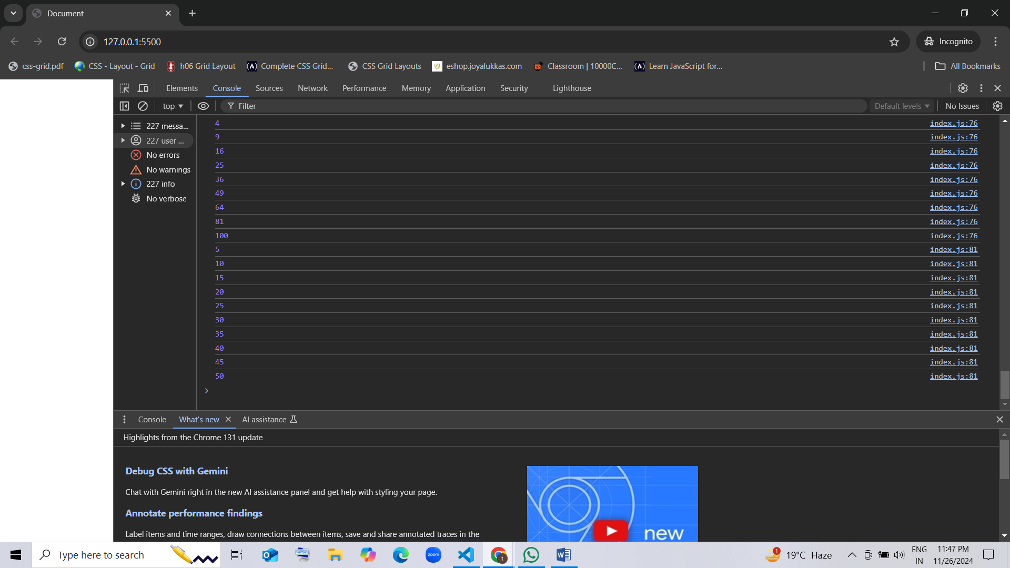

for (var i=1; i<=10; i++) {

    console.log("5 x",i,"=",5*i)

}

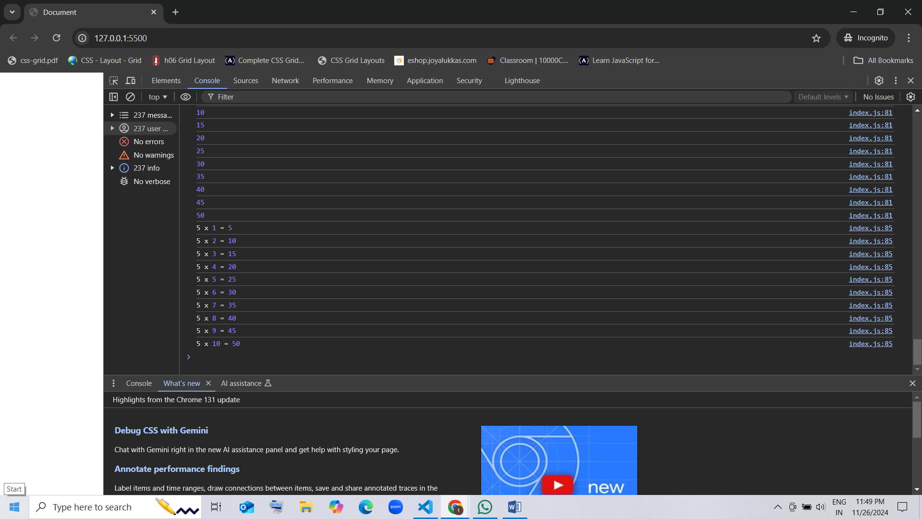

1. **Write a for loop to print numbers from 20 to 1 in reverse order.**

for (var i=20; i>=1; i--) {

    console.log(i)

}

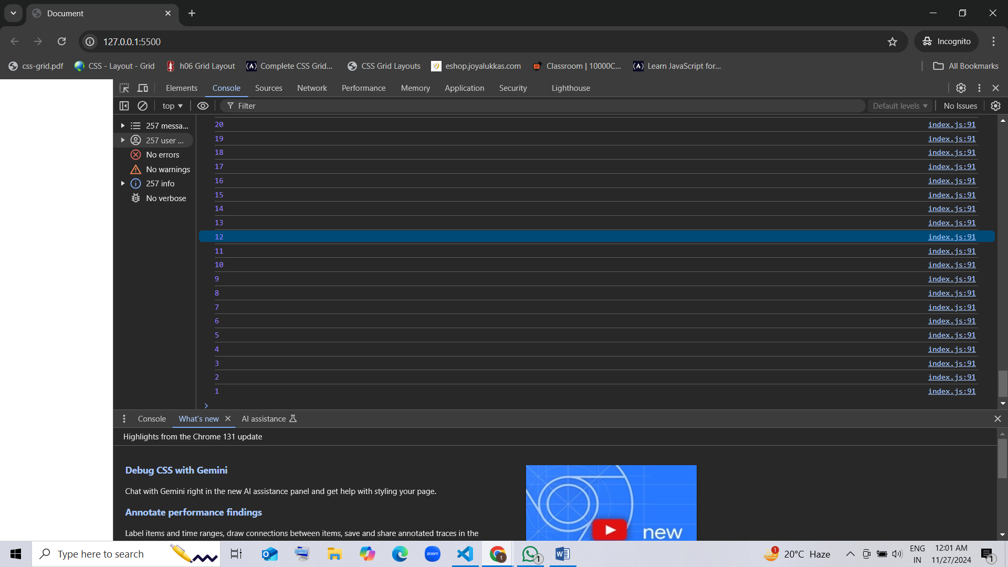

1. **Create a for loop to print the first 10 even numbers in reverse order (e.g., 20, 18, 16, …).**

for (var i=10; i>=1; i--) {

    console.log(i*2)

}

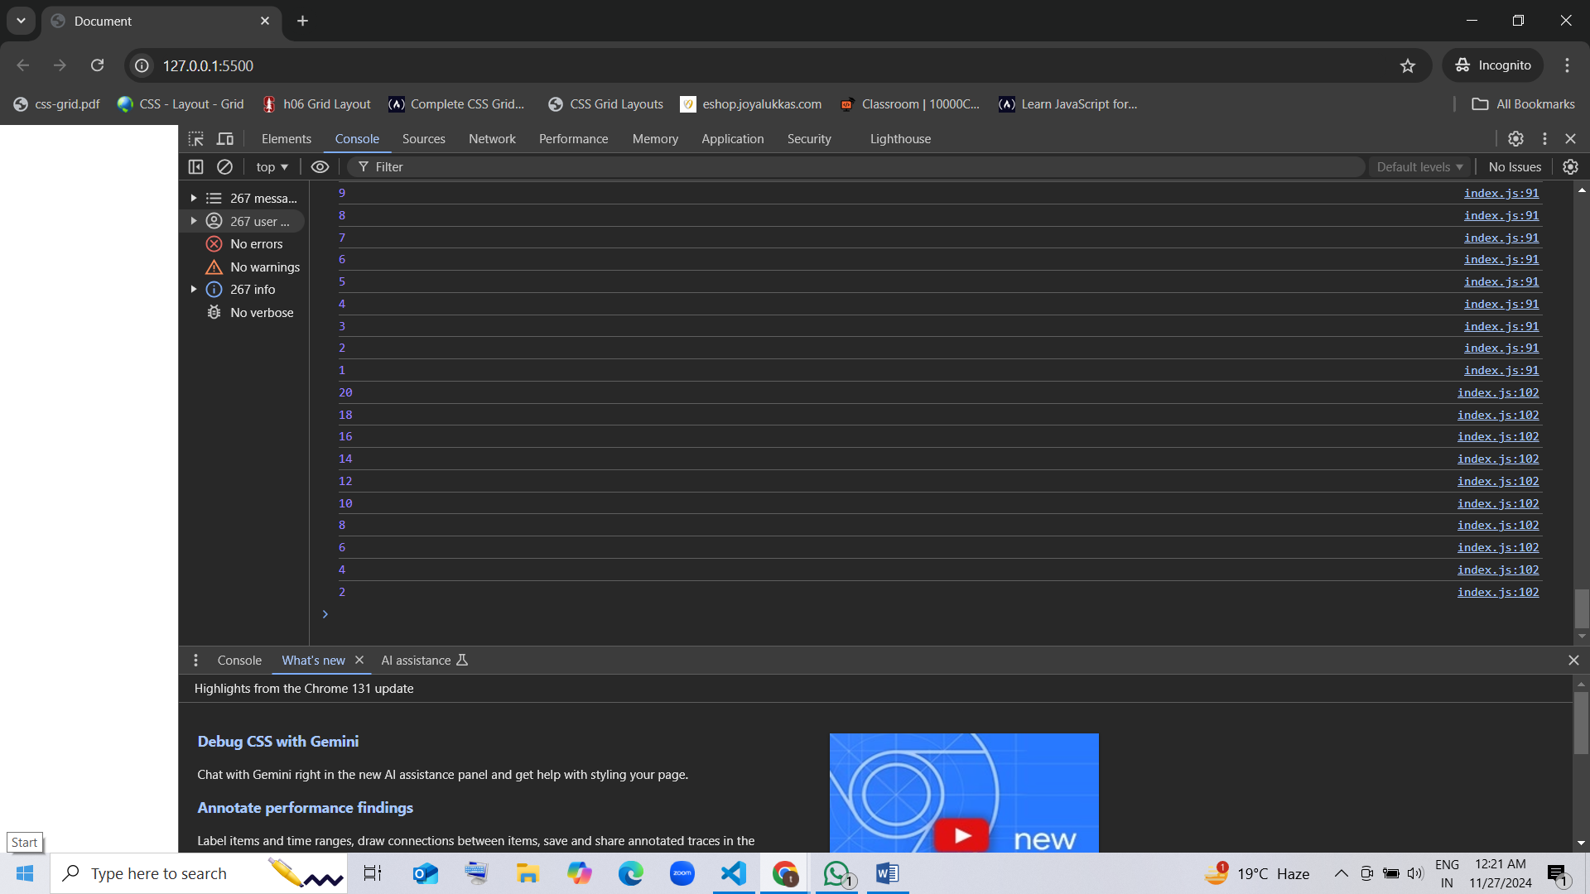

for (var i=20; i>=2; i-=2) {

    console.log(i)

}

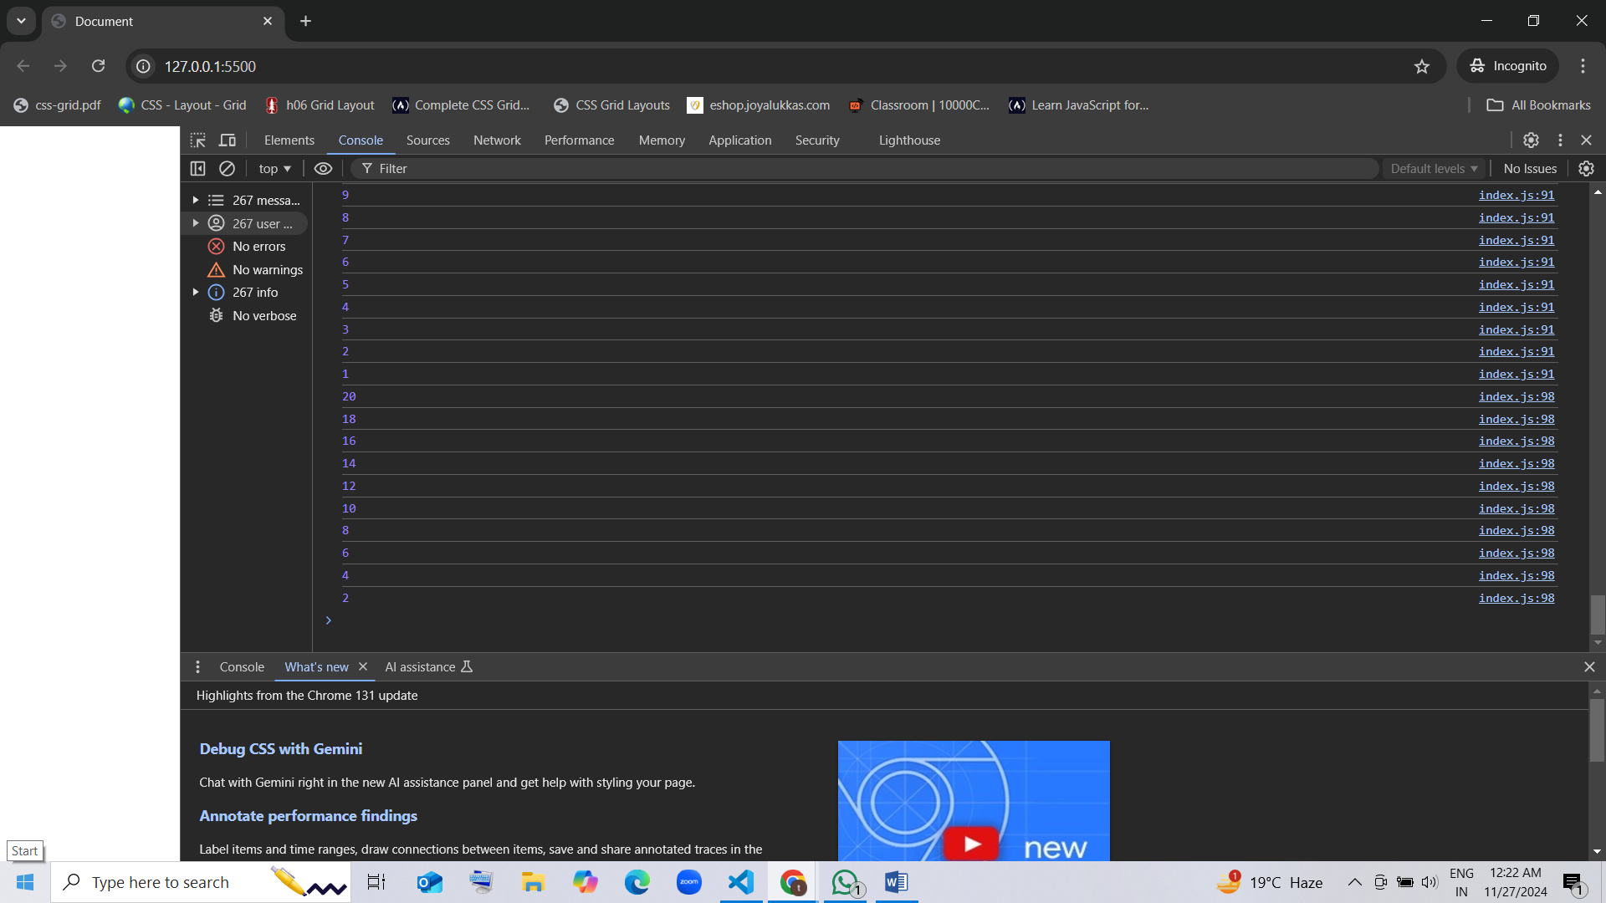

### Array

1. **Print each element of the array**
   * **Input:** [10, 20, 30, 40, 50]
   * **Expected Output:**
   * 10   
     20   
     30   
     40   
     50

arr= [10, 20, 30, 40, 50];

for (var i=0; i<arr.length; i++) {

    console.log(arr[i]);

}

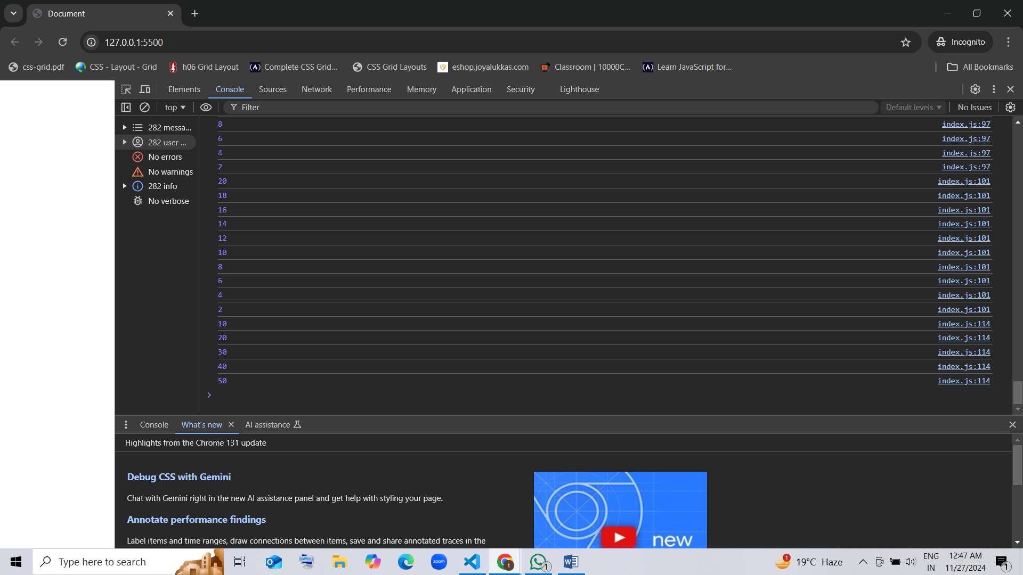

1. **Print the index of each element along with its value**
   * **Input:** ['apple', 'banana', 'cherry']
   * **Expected Output:**
   * Index 0: apple   
     Index 1: banana   
     Index 2: cherry

* arr =["apple","banana","cherry"];
* for (var i=0; i<arr.length; i++ ){
* console.log("Index" + i+ ":"+arr[i])
* }
  + 